**1. Home Page:**

Following snapshot shows the Home page for BookMyMaid

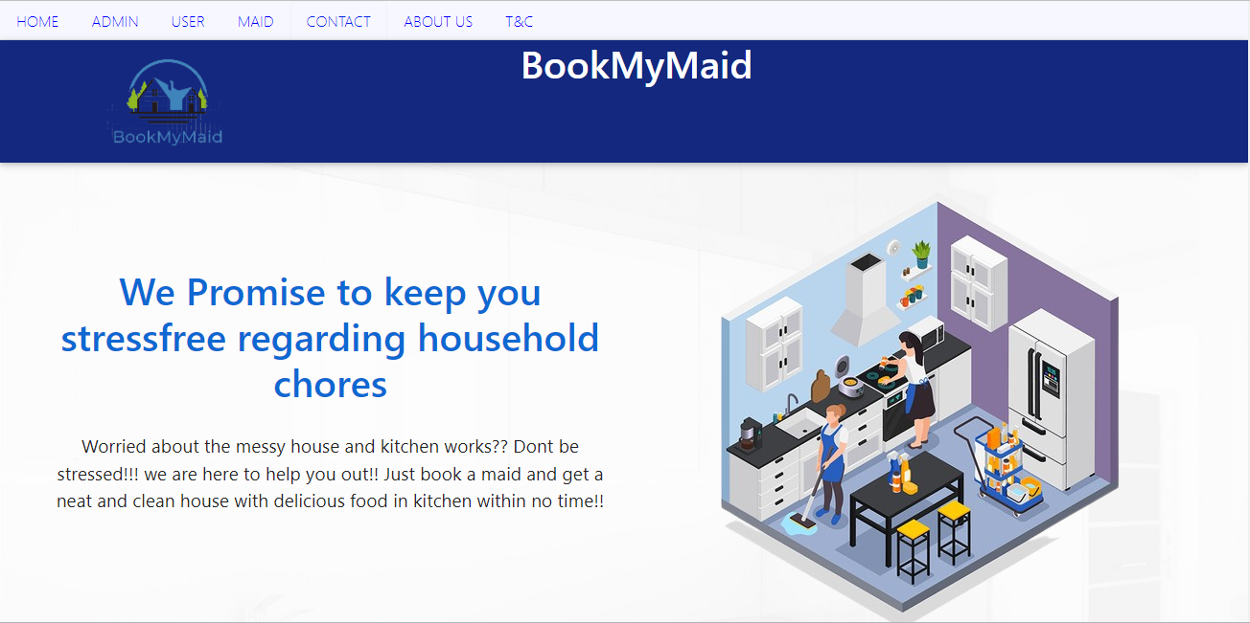

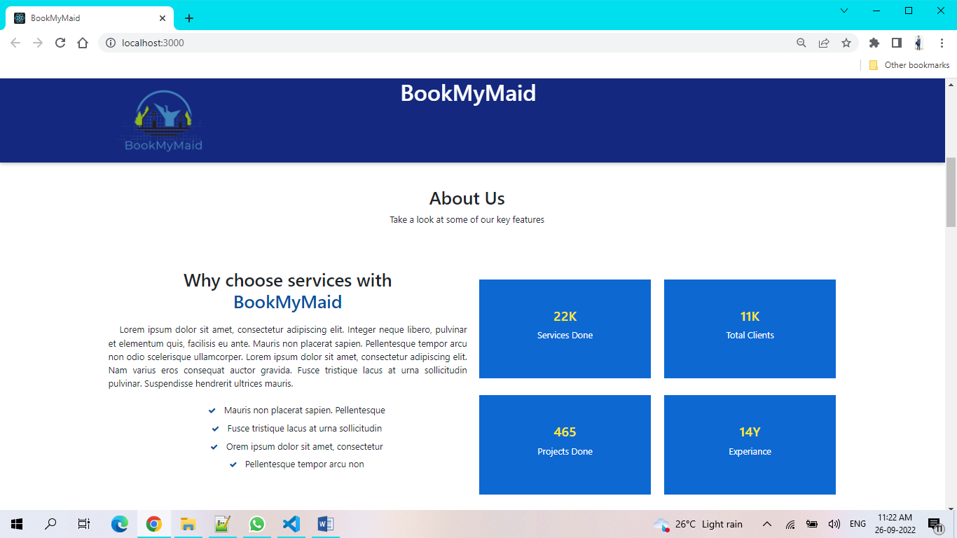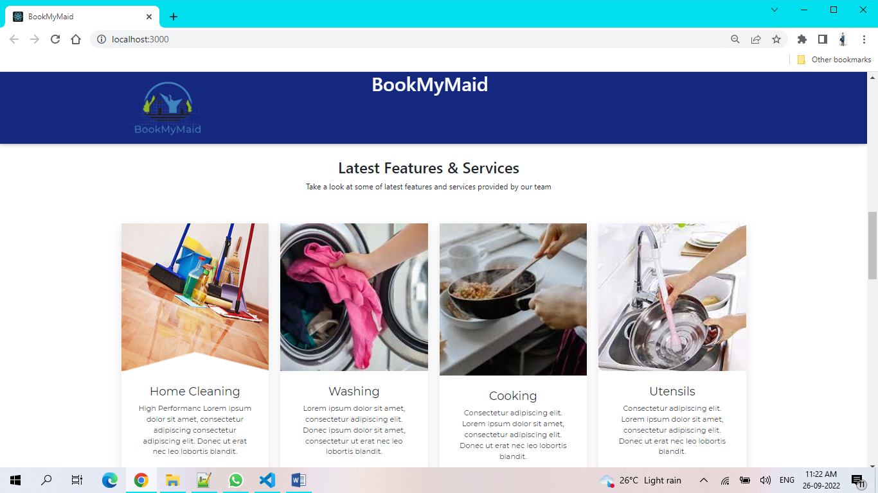

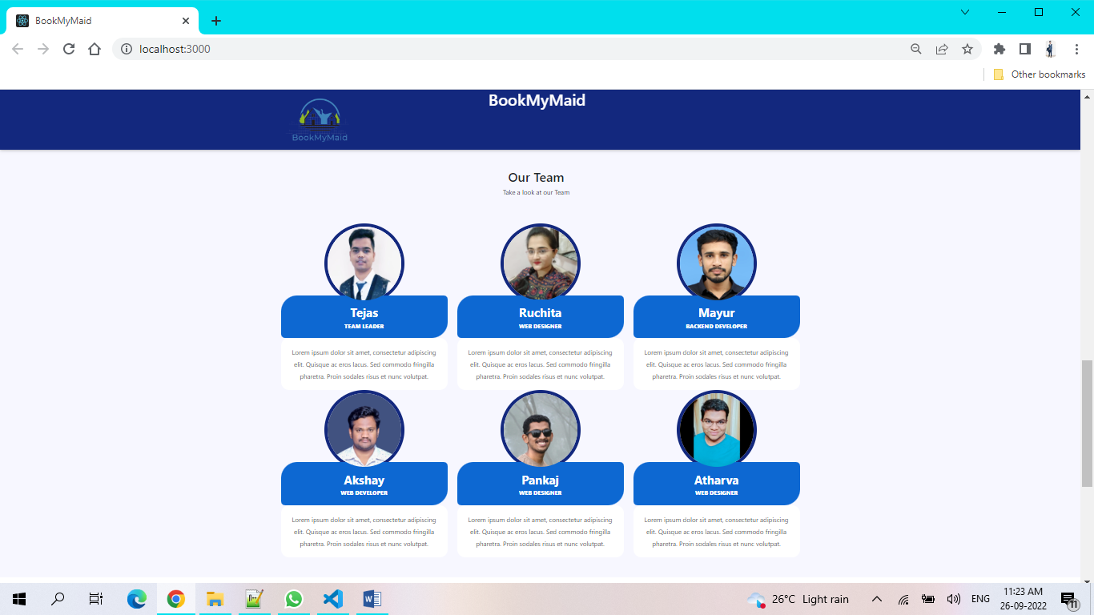

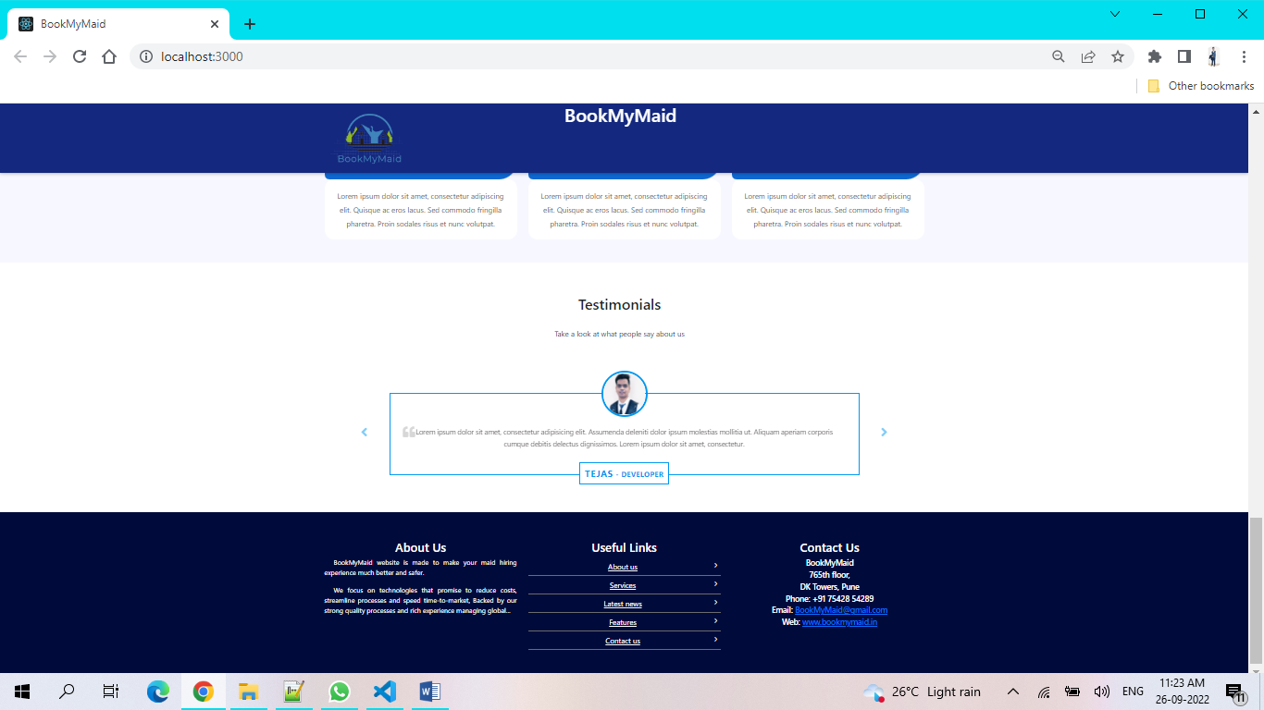

**2. Contact And About US Page**

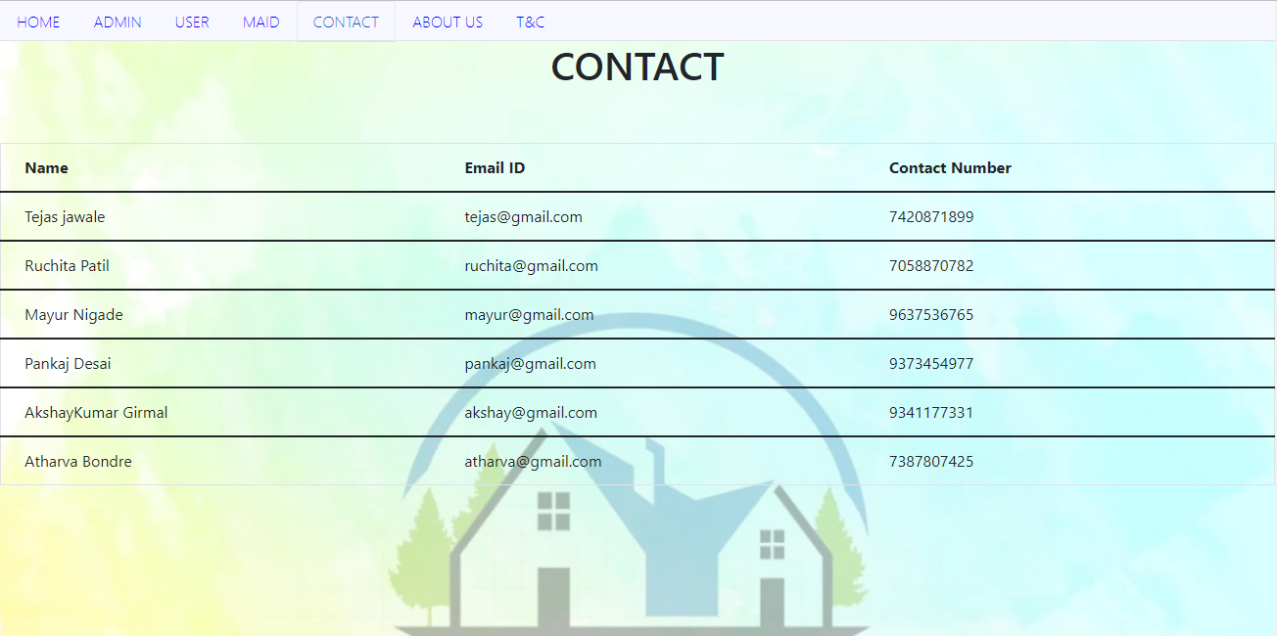

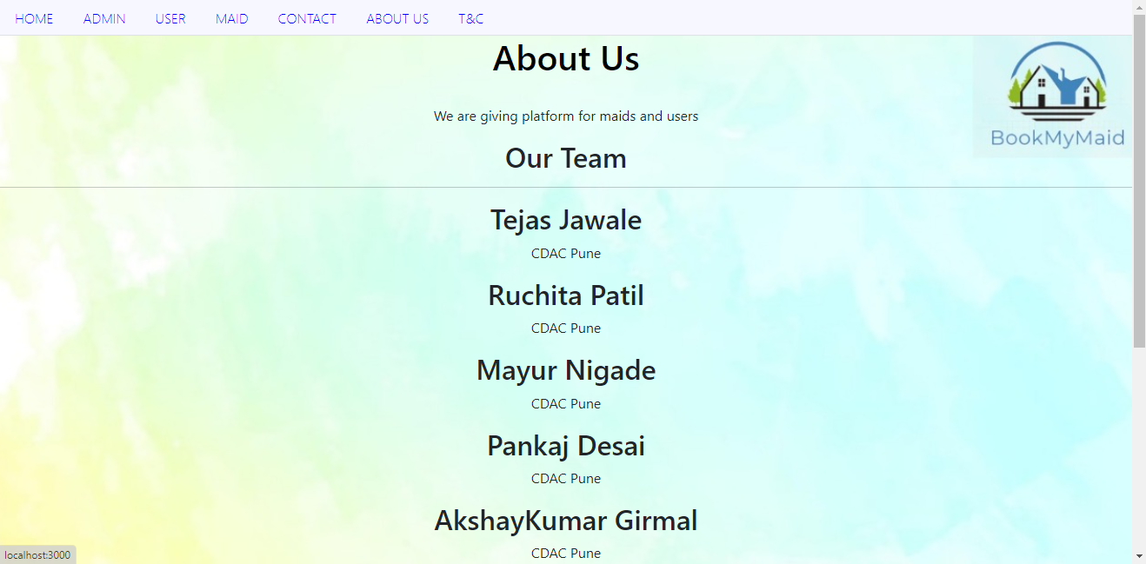

**3. Login Page**

Following snapshot shows the Login page for Admin

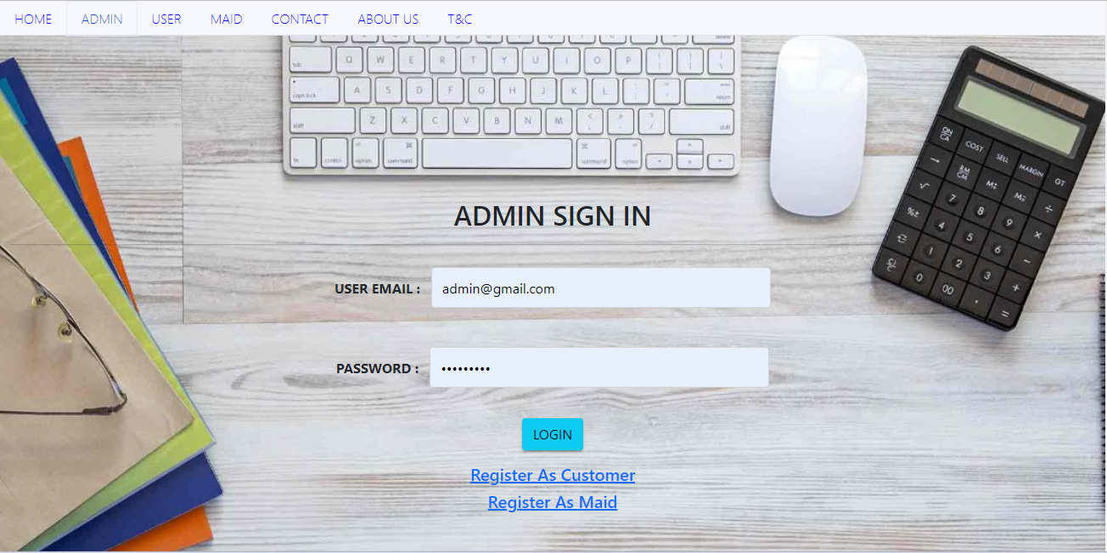

Following snapshot shows the Login page for User

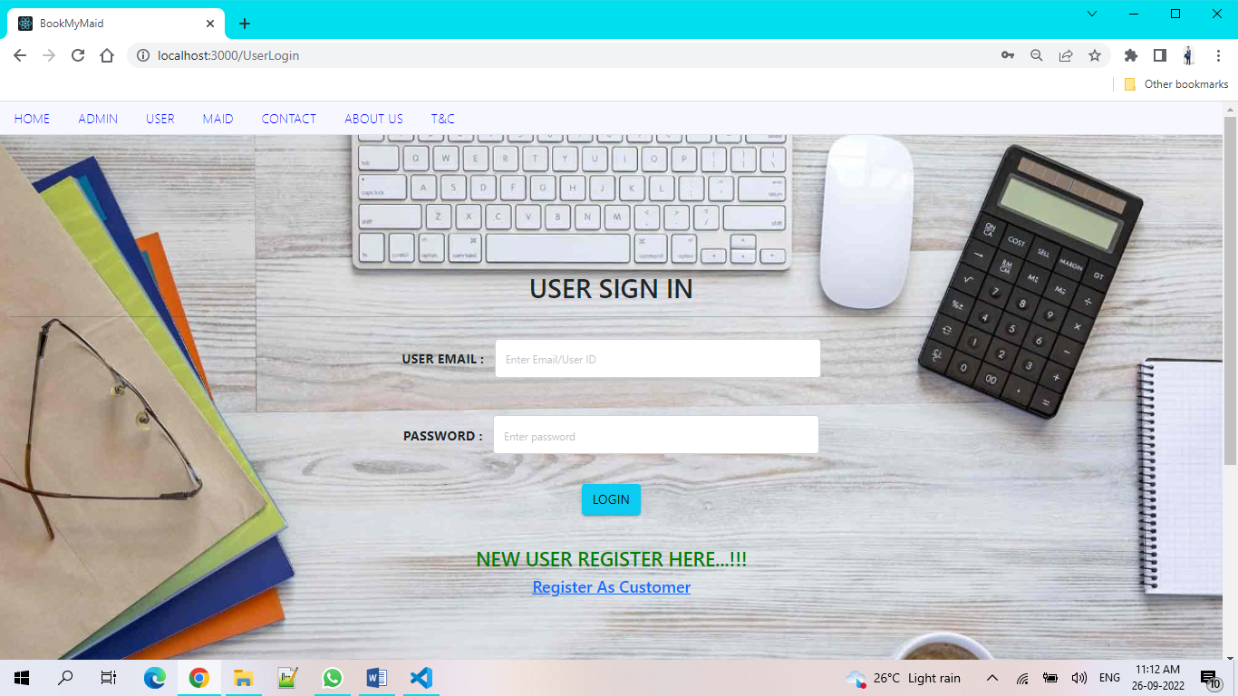

Following snapshot shows the Login page for Maid

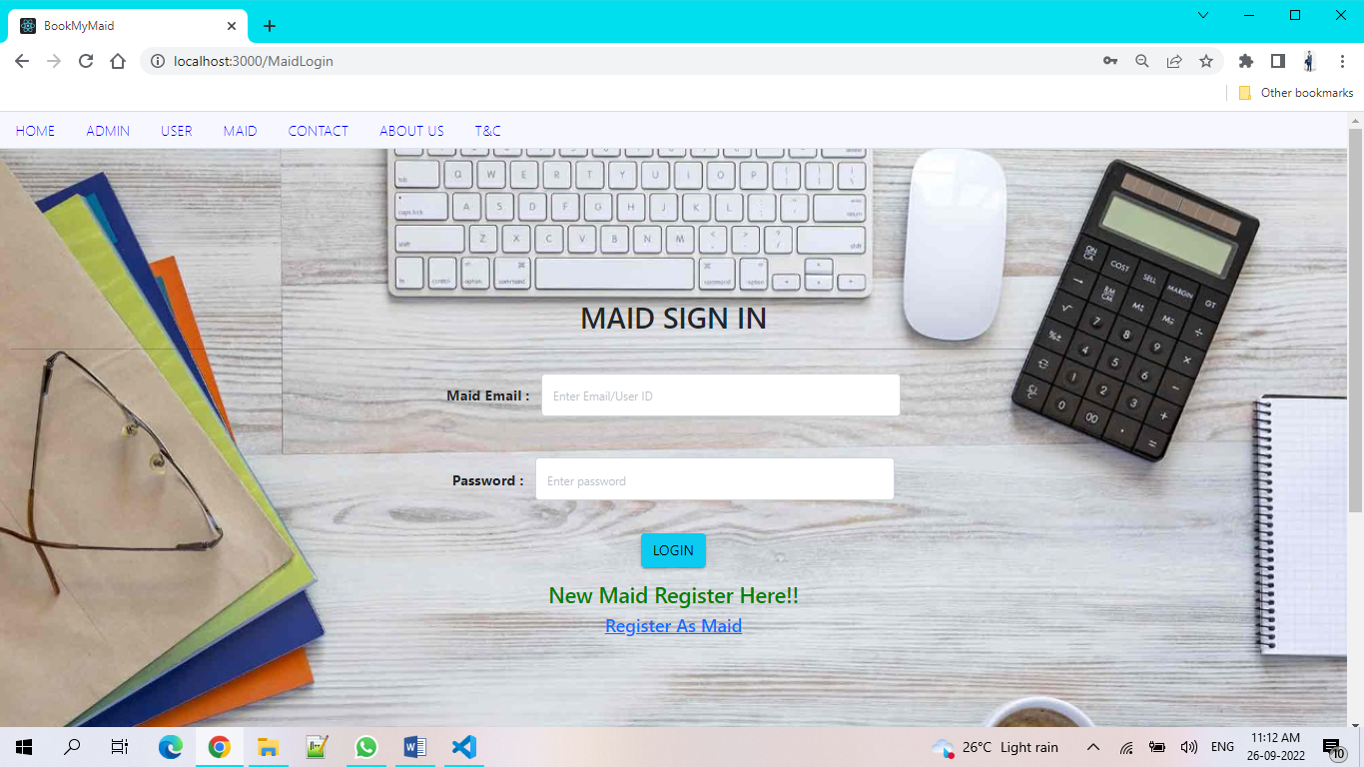

**4. Customer Registration Page**

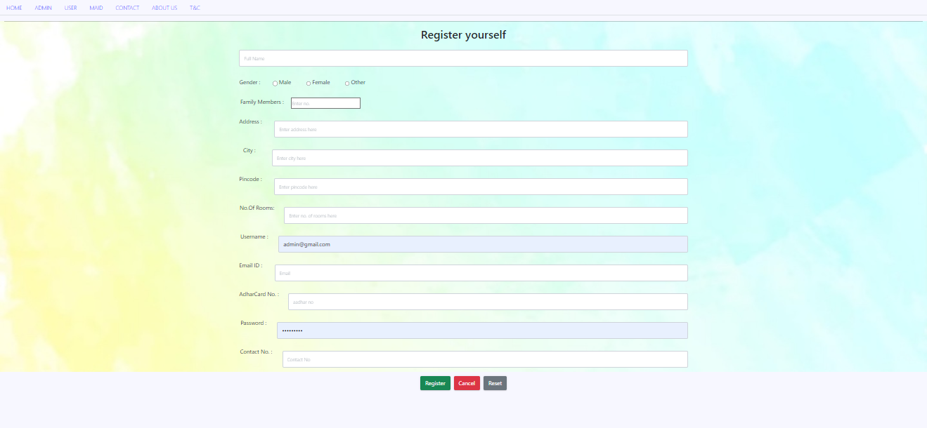

**5. Maid Registration Page**

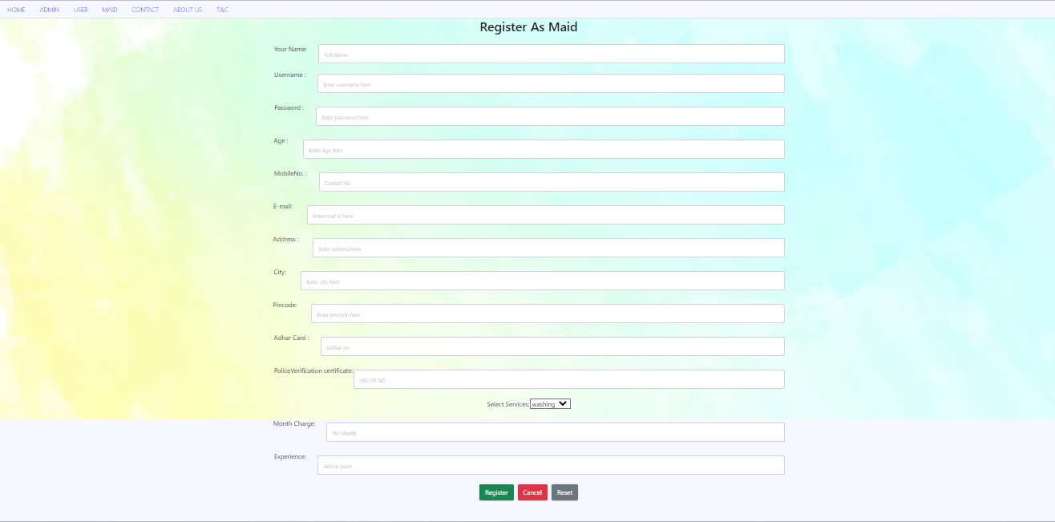

**6. Customer Booking Maid**

**6.1. Customer Home page After Successful login**

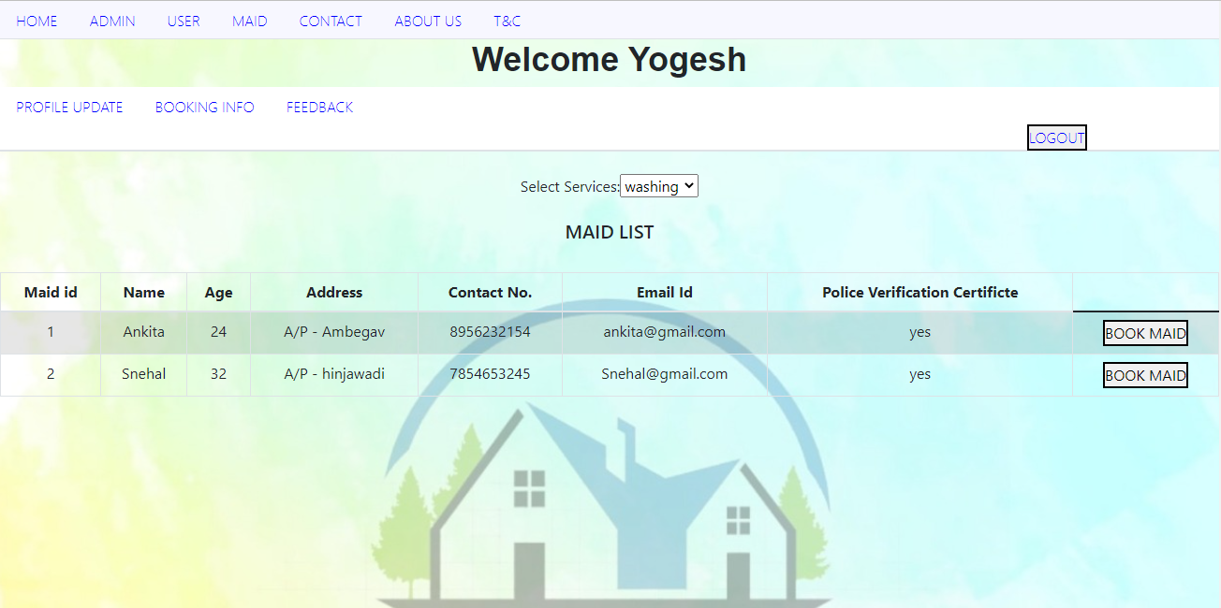

**6.2 Customer Viewing Maid for Category Cleaning**

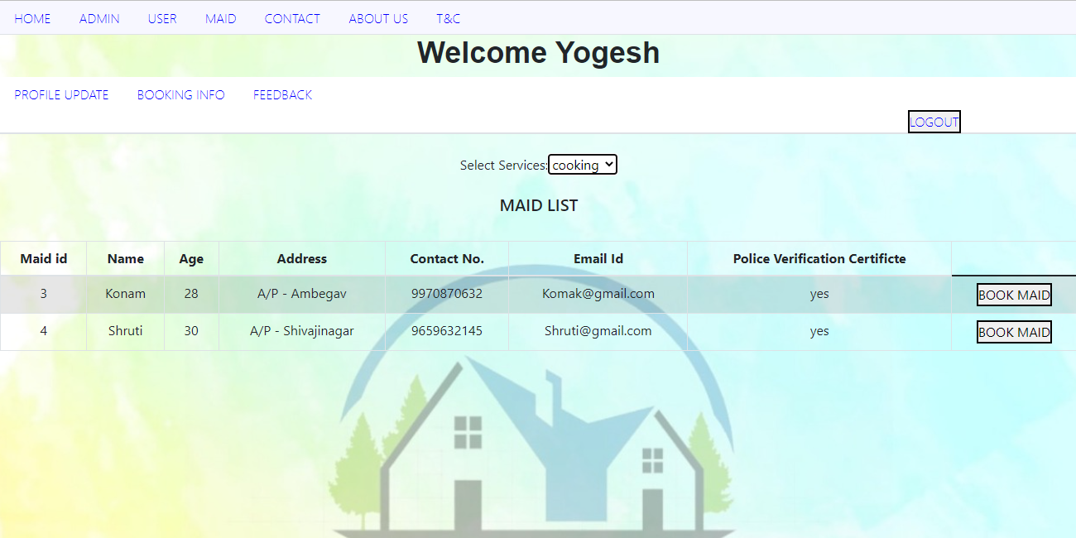

**6.3 Customer Viewing Maid for Category Cooking**

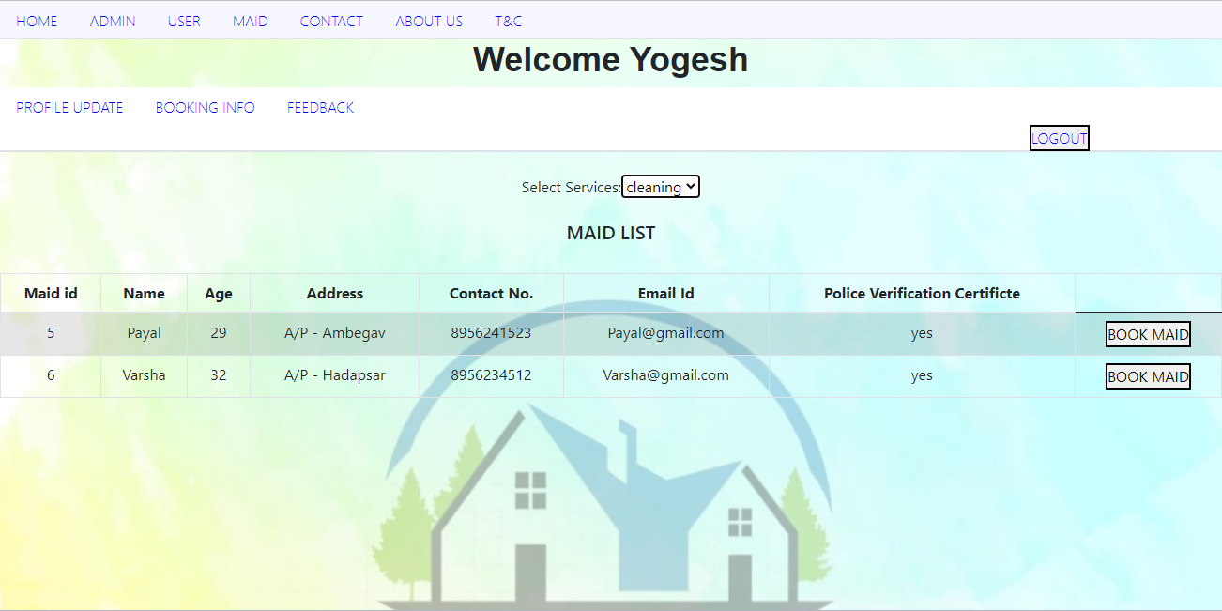

**6.4 Booking Page**

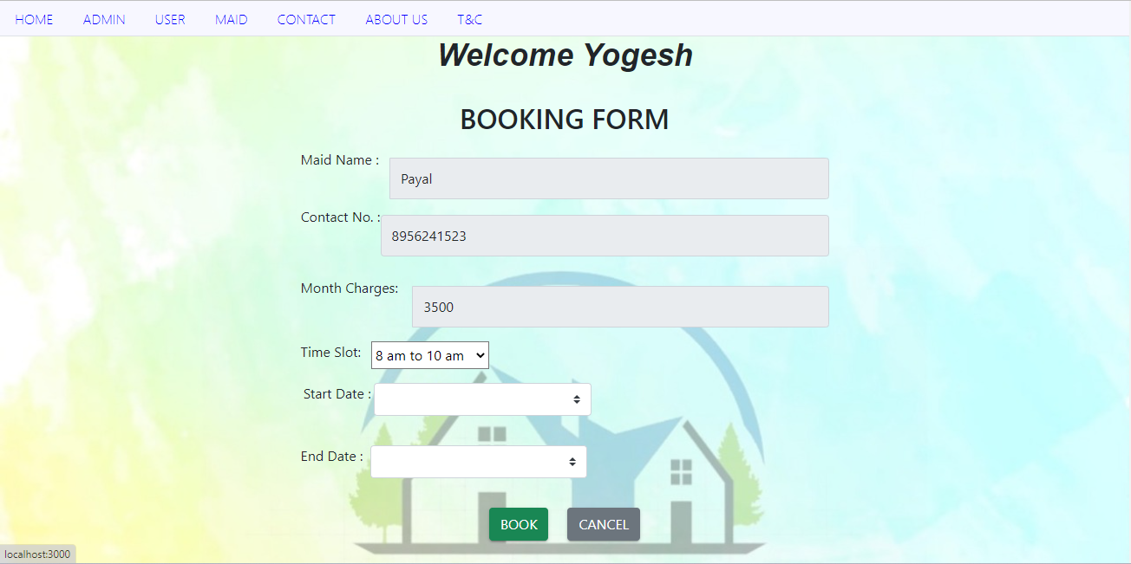

**6.5 Booking Info (the bookings made by customer)**

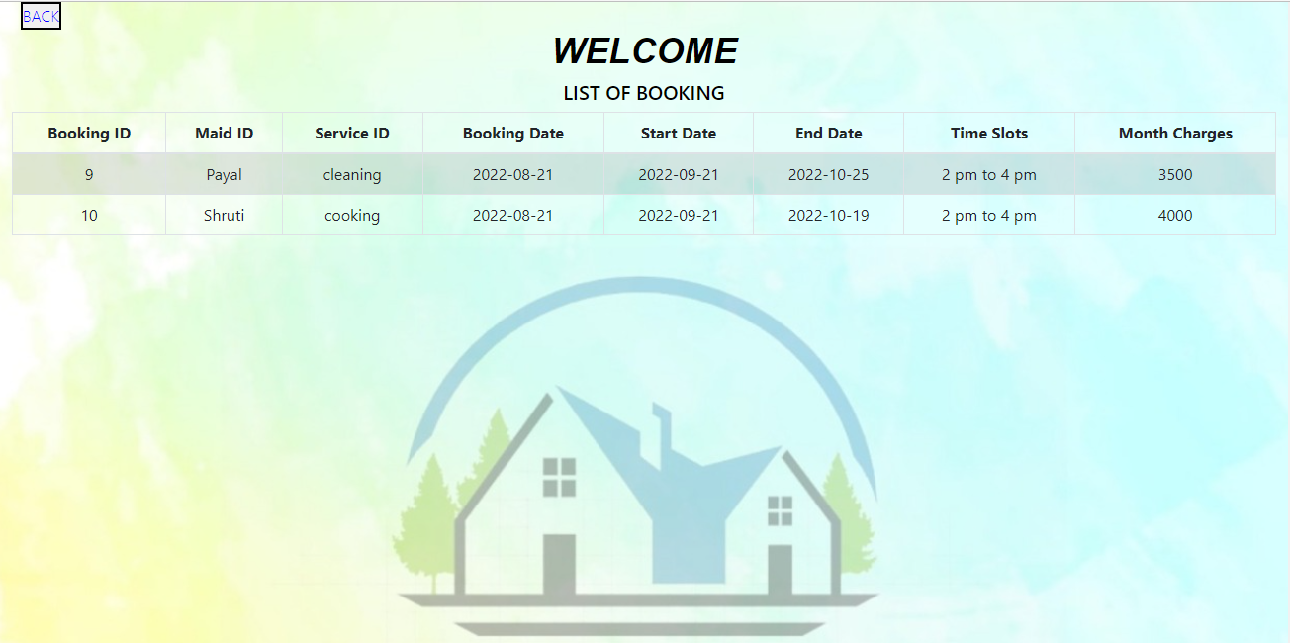

**6.6 Customer Feedback Form**

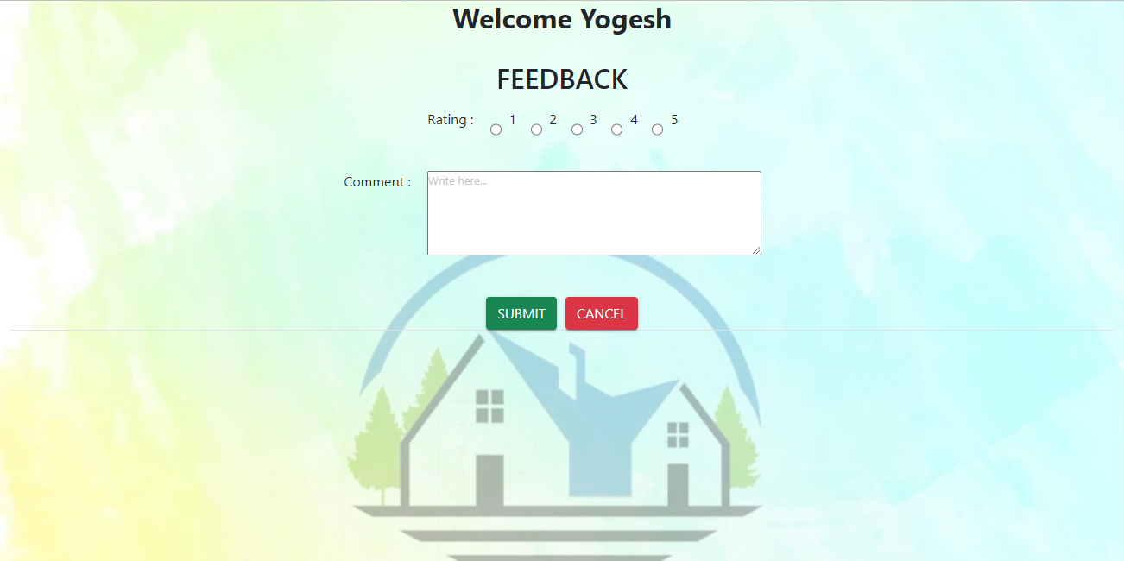

**6.7customer Personal Info(customer can update personal info )**

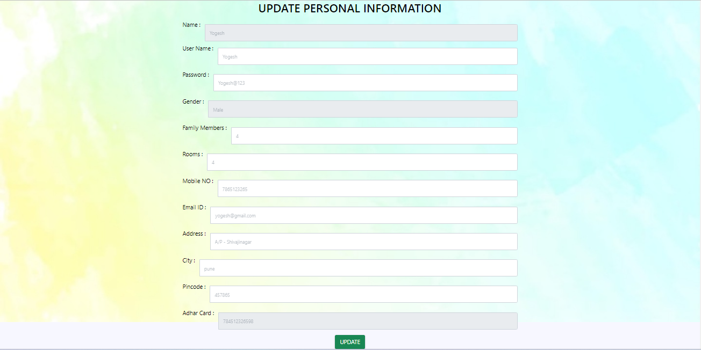

**7. Maid Update Profile Page updated by Admin**

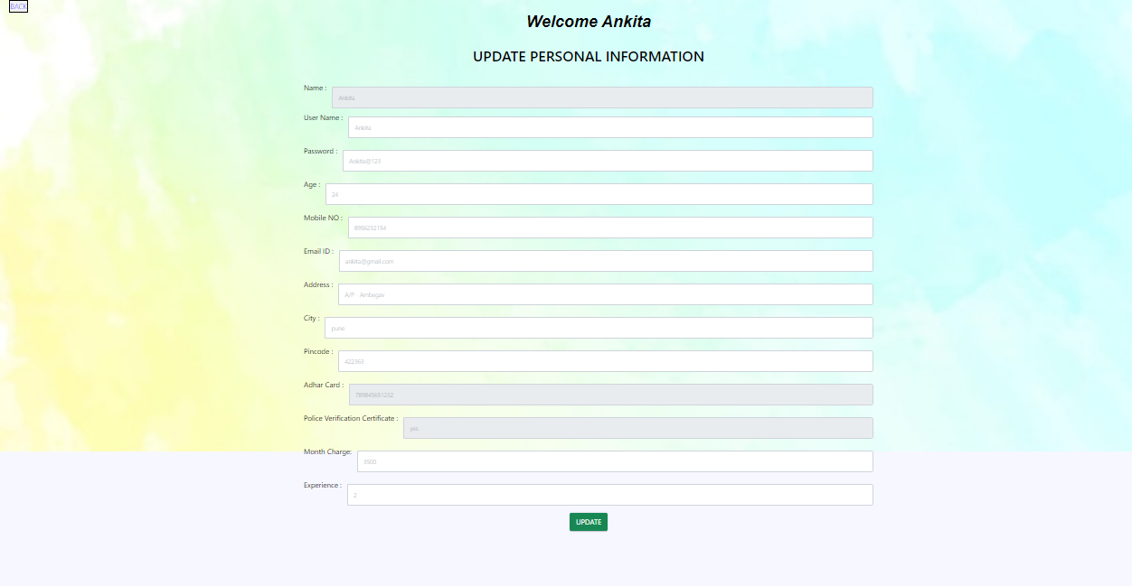

**8 Admin**

**8.1 Admin Home Page**

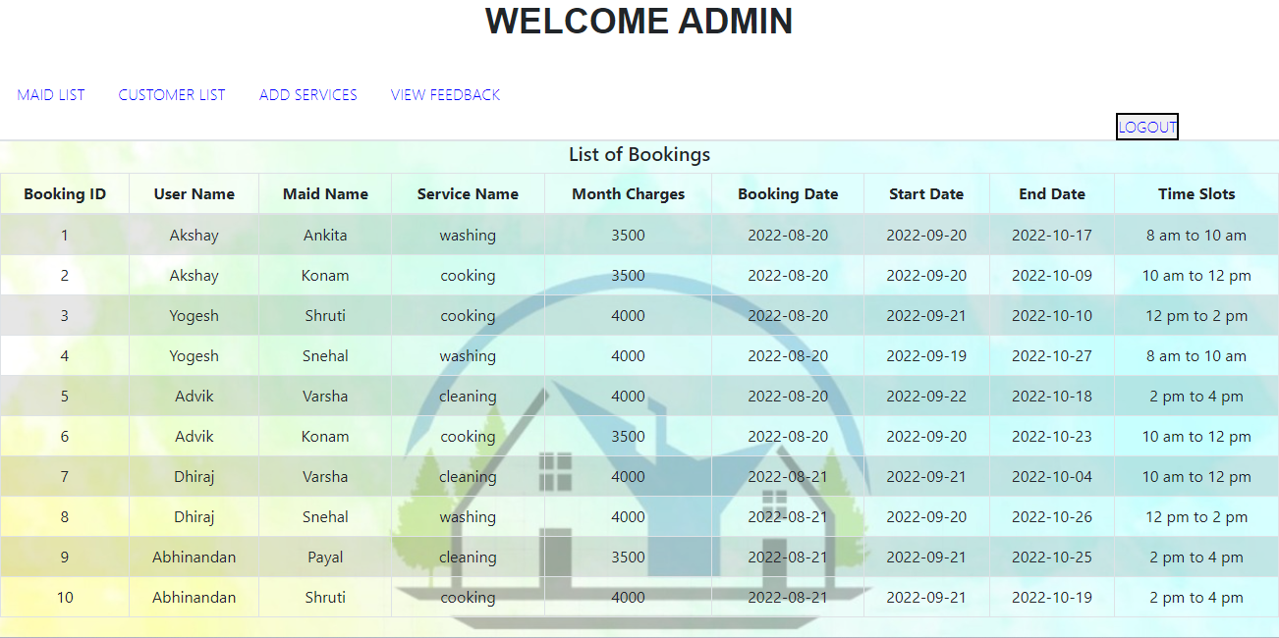

**8.2 Maid Details for Admin**

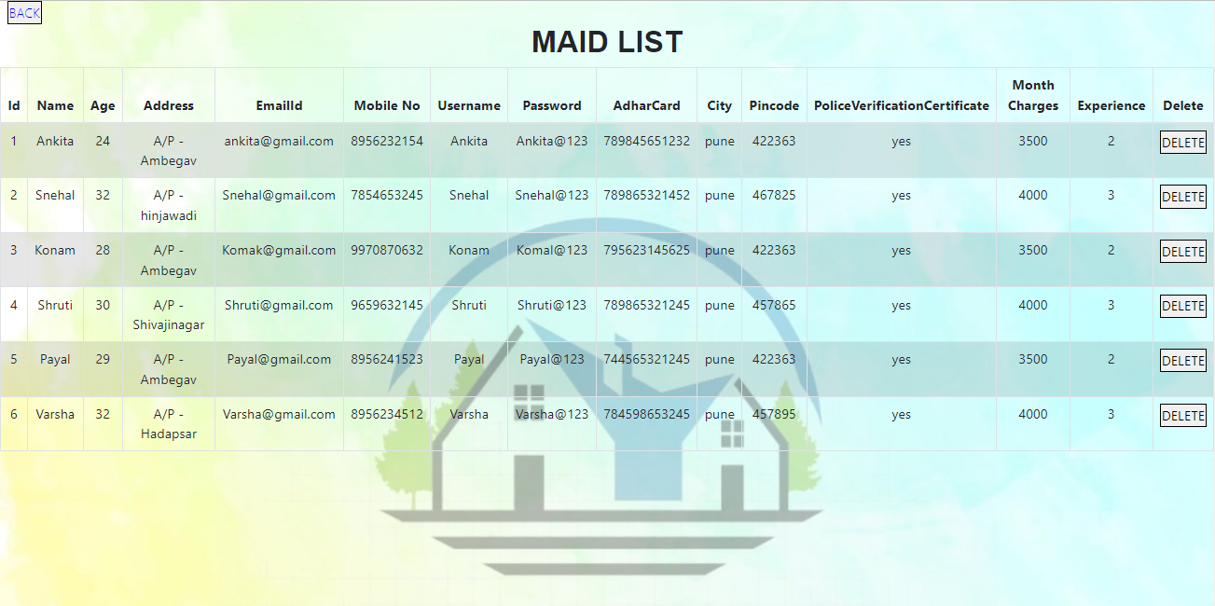

**8.3 Maid Profile Page**



**8.4 Customer Details Page**

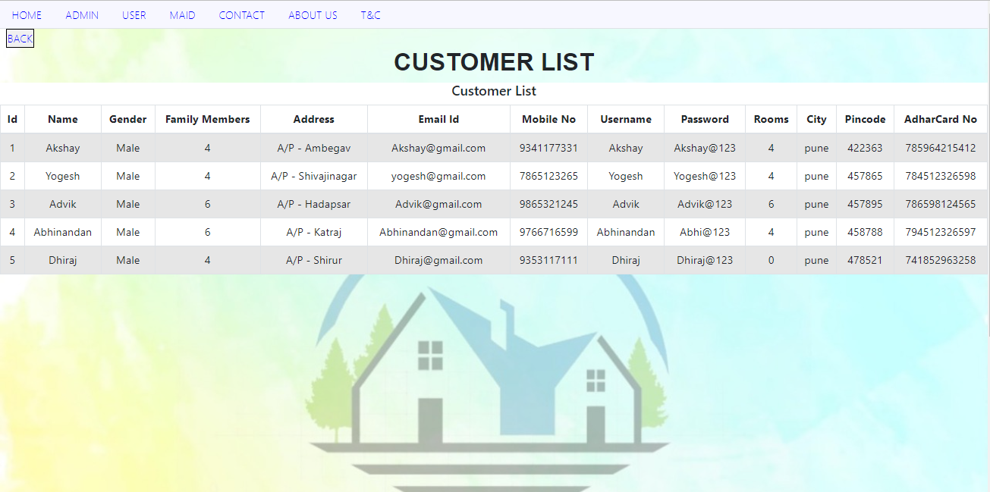

**8.5 List of Feedback given by customer**

